NVASP Monthly OPEN MEETING
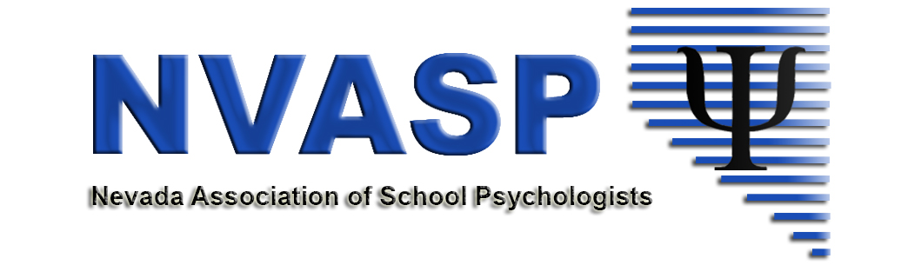
Location: Zoom online (40 m max)
Date: 8/14/2018
Attendees: Stephanie Patton, David Nomicos, Emma Dickinson, Danielle Shaw, Andrea Walsh, Paige Beckwith
Time: 4:00 PM
- Call to order
- Roll call
- Approval of minutes from last meeting
- Open issues
  - Community Agreements- Attached from Retreat.
  - Conference Planning
    - Insurance
    - Expenses/Income
    - Dinner – voting item – on own or paid by NVASP.
    - Audio/video equipment
    - Other
  - Committee Updates
    - Communications
    - GPR/Legislative updates
    - Shortage -upcoming NASP Webinars on Shortages
      - Wednesday, August 15th 1:00 PM PST Utilizing NASP resource to remedy shortages
      - Wednesday, September 12th 3:30 PM PST Communicating about Shortages
      - Wednesday, October 24th 5:00 PM PST, Advocating for Policies for Remediating Shortages
      - Thursday, November 15th, 1:00 PM PST, Building Communities of Practice
    - NASP Delegate Report
  - By-Laws/Website updates
  - The Will to Govern Well -future work
- New business
  - Zoom account $14.99/month, $180
  - Conference Procedures – future work
  - Other
- Adjournment

