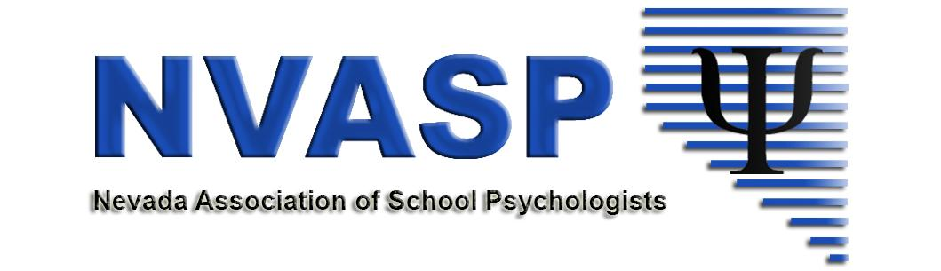
NVASP Monthly OPEN MEETING
Location: Zoom online
Date: 01/15/2019
Attendees:
Time: 4:00 PM
- Call to order
- Roll call
- Approval of Minutes –Last Meeting
- Open Issues – I = Information, A= Action, D= Discussion
  - Happy New Year!! Celebrations – (professional, personal, anything!!!)
  - (All-I) Community Agreements (Don’t be afraid to speak up, agree or disagree respectfully, others?)
  - (All, A, I) Conference Follow-ups
    - Procedures/policies for the future - in process with Tim, Andrea W and myself
  - (D, All) Communication
    - Posting of the minutes
  - (All- A, D) NVASP Short Term Goals: https://docs.google.com/document/d/115n57LOGe--0fOwJLOnNsq9ImoeeTA7MbcEvpH7vd64/edit?usp=sharing
    - New goal possibilities added - WTGW- David
  - Planning for the 2019-20 Lecture Series
    - Organization
      - Who leads? Crisy Perkins, south director? Need a point person in N & S.
      - Separate meetings with updates in the monthly NVASP agenda
    - Monthly speakers? Bi-monthly? September - June = 9 speakers
    - Speakers- possibilities - ALL TENTATIVE
      - Dr. Ortiz (others through MHS?) wants to come in Fall 2019. What date would we like him to come out?
      - Dr. Lansing from UNR- Pain Specialist- new contract with WCSD is pending for Spring
      - Dantzig, Fentiman, Duris -Ordinal Scales of Development: Cognition (no contact made yet)
      - Dr. Susan Risi - ADIR Training
      - Repeat of Russell Lehmann
      - Dr. Ericka Ryst
      - Other ideas? Locals? Dr. Sam Song?
  - (I) Position, Committee and Task Force Updates
    - (D. Shaw) Financial Updates
    - (S. Patton) Communications Director
    - (K. Dockweiler) GPR/Shortages - gearing up for the next legislative session.
      - Work with the Collaborative - letter regarding bills?
    - (A. Walsh) NASP Delegate Report
      - Who is attending RLM?
      - NVASP Sponsored RLM participants - Reimbursement procedures? Is a form needed?
      - Other
    - (I, P. Beckwith) UNR Task Force Update
  - Tabled/Ongoing
    - (All – D) By-Laws/Website updates
    - (D, A) NVASP Awards/Recognitions
- New business
  - Next meetings will be every Third TUESDAYS of the month: Feb 19, March 19, Skip April, May 21.
  - Next Safe and Respectful Learning Environment Meeting will be January 28th from 11-4:00.
- Adjournment

