NVASP Monthly OPEN MEETING
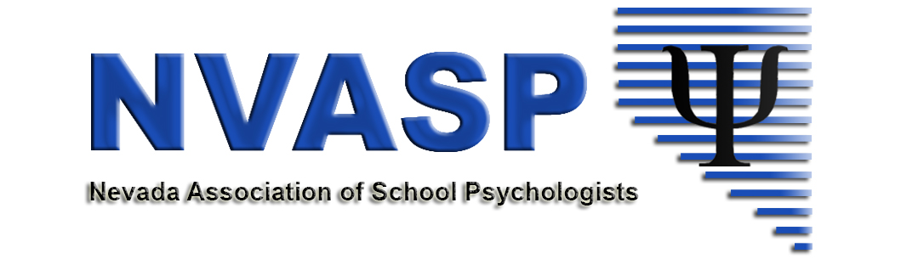
Location: Zoom online
Date: 10/18/2018
Attendees:
Time: 4:00 PM
- Call to order
- Roll call
- Approval of Minutes –Last Meeting
- Open Issues – I = Information, A= Action, D= Discussion
  - Celebrations – professional, personal, anything!!!
  - (All-I) Community Agreements- Attached from Retreat.
  - (All- I) Conference Debrief and Follow-ups
    - (D. Shaw) Financial update
    - Reimbursements
    - Procedures/policies for the future – delegate writing team
  - (D, All) Communication – update on Google Drive.
  - (All-A) Approval of Outside Research/Electronic Requests Policy
  - (All –D, A) NASP State Resource Credentialing Specialist (SRCS)
  - (All- D) NVASP Short Term Goals: What do we want to accomplish in the next two years?
  - (I, D) Leadership in Action Spotlight (liAS)- Nominations submitted? Timeline?
  - (I) Committee and Task Force Updates
    - (S. Patton) Communications (SPAW and NASP Webinar)
    - (K. Dockweiler) GPR/Legislative updates
    - (T. Guenther) Shortages -upcoming NASP Webinars on Shortages
      - Thursday, November 15th, 1:00 PM PST, Building Communities of Practice
    - (A. Walsh) NASP Delegate Report
      - Registration for RLM
      - NVASP Sponsored RLM participants
    - (I, P. Beckwith) UNR Task Force Update
  - (All – D) By-Laws/Website updates
  - (E.Dickinson-D) The Will to Govern Well -future work
- New business
  - (D, A) NVASP Awards/Recognitions
- Adjournment

